PeakBirch Logic Announces the Acquisition of Stul Ltd
Acquisition Accelerates Goal to Expand Sales Channels and Reach the E.U./U.K. Market

PeakBirch announces the acquisition of Stul Ltd. and its brand Hot Box Herb, a leading Headshop in Chelmsford, Essex.
Vancouver, Canada, July 29 – PeakBirch Logic Inc. (CSE: PKB) (FSE: KYH2) (OTCQB: KTNNF) ("PeakBirch" or the "Company") is pleased to announce the closing of the acquisition (the "Acquisition") of Stul Ltd. ("Stul" or the "Seller"), located in London, United Kingdom. PeakBirch has acquired all of the issued and outstanding shares of Stul, including all of the existing assets of Stul, for a purchase price (the "Purchase Price") of 250,000 GBP (Cdn$432,425) payable by the issuance of 10,810,625 (the "Compensation Securities") common shares of PeakBirch ("Common Shares") at a price of $0.04 per Common Share.

8,648,023 Common Shares were issued to the sole shareholder of Stul on the closing of the Acquisition, and the remaining 2,162,600 Common Shares will be issued upon Peakbirch confirming that Stul's working capital is at least GBP350,000 (the "Working Capital Target"). In the event Stul's working capital is less than the Working Capital Target, the Purchase Price (and accordingly the number of Common Shares issuable under the Acquisition) shall be reduced on a dollar-for-dollar basis. Assuming that all of the Compensation Securities are issued, the former shareholder of Stul will hold 10,810,625 Common Shares representing 9.91% of the Common Shares and will not beneficially hold any other securities of PeakBirch.

Transaction Details

- As part of the Acquisition, PeakBirch acquired Hot Box Herb, a leading brick and mortar cannabis accessory shop (a headshop) and e-commerce website. Based in Chelmsford, Essex, the headshop has become Southern England's most reputable cannabis accessory shop within only 3½ years of being open and offers the largest selection of quality cannabis accessories and products in the region with over 1800 active SKUs. The addition of the Hot Box Herb brand will help PeakBirch establish a foothold in the U.K. market with a retail store in a premium location and an online e-commerce site. Hot Box Herb has generated over 1 million GBP in revenue, and since then, e-commerce sales have grown by 149%. PeakBirch is well-positioned to capitalize on this growing market and expand CBD sales with foot traffic to retails stores; expected to increase as COVID-19 restrictions are lifted and in-person office work resumes. Additionally, key personnel retained in the deal can provide insights into the local market and provide local staff knowledge for marketing initiatives.

- Hot Box Herb owns and manufactures its own organic branded CBD, named New Era Wellness ("New Era"), consisting of a product line of topicals, edibles, and flower. New Era is one of Europe's premier consumer CBD companies, with 150% year-over-year ("YOY") sales growth and an average gross margin of 200%. PeakBirch anticipates increasing the value of the New Era brand by expanding brand coverage and products to more stores and online retailers and increasing B2B sales.

- With the acquisition of Stul, PeakBirch will receive 350K GBP in working capital which includes approximately 150K GBP in inventory, including shisha, tobacco and pipes, cannabis accessories, high-end designer bongs, and CBD.
- PeakBirch acquired Stul's a portfolio of websites and domains, including "www.hotboxherb.com."
- PeakBirch acquired the following trademarks: New Era, New Era Wellness, Used Filter, and Hot Box.

With the acquisition of Stul, the Hot Box Herb brand, and New Era Wellness product lines, PeakBirch plans to:

- Create a glass brand for B2C and B2B resale
- Grow CBD sales by selling to other businesses through pop-up shops and set up in local markets
- Increase online and store sales through marketing initiatives and brand awareness campaigns
- Leverage existing relationships with brands in the U.S. and Canada by providing opportunities to expand their brand presence in-store and online
- Set up a national drop shipping program for other businesses
- Promote the New Era Wellness brand for CBD and expand offerings to include B2B sales

The U.K. legalized cannabis market is expected to be worth USD 4.3 billion by 2024. Therefore, this deal provides an excellent growth opportunity to expand the family of PeakBirch services and products across Europe.

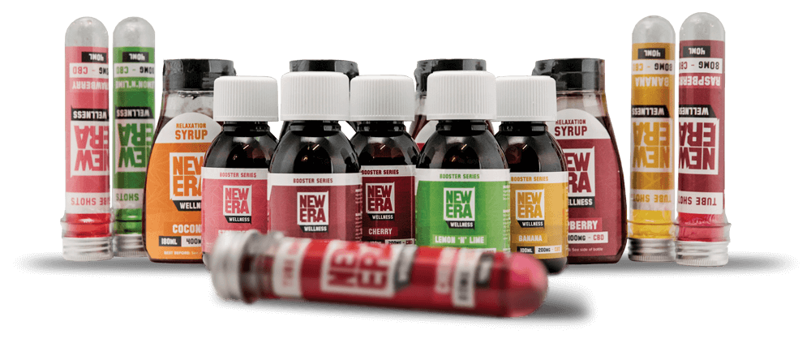
As part of the Transaction, the Company will acquire New Era Wellness branded CBD
"This acquisition is the first stepping stone we felt we needed to take to establish a foothold in the U.K. using the Hot Box Herb brand," said Marc Mulvaney, CEO of PeakBirch. "We are very excited to be welcoming our new experienced team members to the PeakBirch family. With the new addition of a brick and mortar store, this allows PeakBirch to run beta tests on their same day delivery platform that is planned to be resold to other businesses."
About PeakBirch Logic Inc.

PeakBirch is a data and sales driven technology organization with the goal to construct a global micro warehousing network for small businesses. This enables shop owners to provide Same-Day Delivery services to their customers and provides them with a sales platform to share inventory within PeakBirch's proprietary A.I. inventory management ecosystem.

Information on the Company and its many products and services can be accessed through the links below: www.peakbirch.com

About Stul Ltd.

Stul Ltd. is located in London, United Kingdom, and owns and operates stores specialising in CBD and cannabis accessories, including New Era Wellness, one of Europe's premier consumer CBD and natural health products companies. New Era Wellness is a world innovator in CBD-infused products and uses CBD extracted with cutting edge methods to create innovative and high-quality CBD products with great value. Its mission is to focus on research and development to produce the best and most versatile hemp extracts and make them accessible worldwide.

Contact
Marc Mulvaney, CEO
Phone: (725) 218-3097
Email: investors@peakbirch.com

This news release does not constitute an offer to sell or a solicitation of an offer to buy any of the securities in the United States. The securities have not been and will not be registered under the United States Securities Act of 1933, as amended (the "U.S. Securities Act") or any state securities laws and may not be offered or sold within the United States unless registered under the U.S. Securities Act and applicable state securities laws or an exemption from such registration is available.

Neither the Canadian Securities Exchange nor its regulations services provider have reviewed or accept responsibility for the adequacy or accuracy of this release.

Cautionary Note Regarding Forward-Looking Information and Statements

This news release may include forward-looking statements that are subject to risks and uncertainties. All statements within, other than statements of historical fact, are to be considered forward looking. Although the Company believes the expectations expressed in such forward looking statements are based on reasonable assumptions, such statements are not guarantees of future performance and actual results or developments may differ materially from those in forward-looking statements. Factors that could cause actual results to differ materially from those in forward-looking statements include the cost of goods to be sold under the Company's drop-shipping model, changes in government regulations or enforcement, the ability for the Company to expand its U.S. operations or expand to international markets, continued availability of capital and financing, and general economic, market or business conditions. There can be no assurances that such statements will prove accurate and, therefore, readers are advised to rely on their own evaluation of such uncertainties. We do not assume any obligation to update any forward- looking statements except as required under the applicable laws. This press release contains forward- looking statements. The use of any of the words "anticipate", "continue", "estimate", "expect", "may", "will", "project", "should", "believe" and similar expressions are intended to identify forward-looking statements. Although the Company believes that the expectations and assumptions on which the forward-looking statements are based are reasonable, undue reliance should not be placed on the forward-looking statements because the Company can give no assurance that they will prove to be correct. Since forward-looking statements address future events and conditions, by their very nature they involve inherent risks and uncertainties. These statements speak only as of the date of this press release. Actual results could differ materially from those currently anticipated due to a number of factors and risks various risk factors discussed in the Company's listing statement under the Company's profile on www.sedar.com.

https://prohibitionpartners.com/reports/#the-uk-cannabis-report

