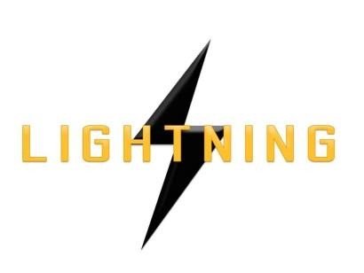

Lightning Ventures Inc.
Suite700-838 W Hastings Street, Vancouver, BC, V6C 0A6

Lightning Ventures Appoints Robert Tjandra to Board of Advisors

VANCOUVER, CANADA, October 17th, 2017 – Lightning Ventures Inc. (CSE: LVI) (Frankfurt: 1HM) (the “Company”) is pleased to announce the appointment of Robert Tjandra to its Board of Advisors.

Mr. Tjandra will lead the Company’s market growth efforts in ASEAN, starting with Indonesia. Indonesia was ranked the 5th top World LNG Exporter in 2016 with proven reserves of 102 TCF. Indonesia rejoined OPEC in 2015 with proven oil reserves stands at 7.2 billion barrels in 2016. Indonesia has 60 sedimentary basins. Unconventional shale gas resources are estimated at 574 TCF.

Mr. Tjandra has extensive oil and gas experience with both national and international companies in emerging markets as well as in developed countries. He started his career working for BP as the first Indonesian national petroleum geologist for BP in Indonesia. His career with BP included a secondment to BP North Sea Operations in Aberdeen, UK.

Mr. Tjandra was born and grew up in Indonesia. He has a unique blend of professional Management / Team Leader and entrepreneurship skill set. He has a B.Sc. in Geology from the University of Toronto and an MBA from the Philippine School of Business Administration.

Don Rainwater, CEO of Lightning Ventures, stated: "Robert Tjandra is a welcome addition to the LVI team. We have been looking at exploiting the technologies we have developed over the years on a larger scale. Robert's exposure to the ASEAN geographic segment will allow us the opportunity to market to a new audience and build accretive value."

About Lightning Ventures

Lightning Ventures Inc. (CSE: LVI) (Frankfurt: 1HM) is an oil and gas industrial services company. It operates a specialty manufacturing business based in Hobbs, New Mexico through its subsidiary Lightning Industries, Inc., which provides products to enhance efficiency and increase the production of oil and gas wells.
Further information about Lightning Ventures is available under its profile on the SEDAR website www.sedar.com and at www.lightningind.com.
For further information on the Company, please contact:
Donald Rainwater
Chief Executive Officer
Lightning Ventures Inc.
Telephone: 210-535-5700
Email: don@rainwater-investments.com
Neither the Canadian Securities Exchange nor its Market Regulator (as that term is defined in the policies of theCanadian Securities Exchange) accepts responsibility for the adequacy or accuracy of this release.

This news release may contain forward-looking statements based on assumptions and judgments of management regarding future events or results. Such statements are subject to a variety of risks and uncertainties which could cause actual events or results to differ materially from those reflected in the forward-looking statements. The company disclaims any intention or obligation to revise or update such statements.

