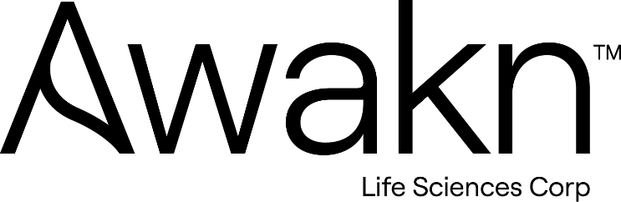

AWAKN LIFE SCIENCES ANNOUNCES CLOSING OF TRANCHE OF PRIVATE PLACEMENT

TORONTO, CANADA, April 17, 2024 – Awakn Life Sciences Corp. (CSE: AWKN, OTCQB: AWKNF, FSE: 954) (“Awakn” or the “Company”) a clinical-stage biotechnology company developing medication-assisted treatments for addiction with a near-term focus on Alcohol Use Disorder (AUD), is pleased to announce that, further to its press release dated April 3, 2024, it has closed a first tranche (the “First Tranche”) of its previously announced non-brokered private placement (the “Offering”) through the issuance of an additional 285,714 units (the "Units") at a price of $0.46 per Unit for additional gross proceeds of $131,428.
Each unit is comprised of one common share in the capital of the Company (each, a “Common Share”) and three quarters (0.75) of one whole Common Share purchase warrant (each whole warrant, a “Warrant”). Each Warrant entitles the holder thereof to acquire one Common Share at a price of $0.63 per Common Share for a period of five (5) years from the date of issuance. Gross proceeds from the Offering will be used to fund the company’s general working capital.
Proceeds of the offering shall be used for general working capital. Closing of the Offering is subject to receipt of all necessary corporate and regulatory approvals, including the approval of CSE Exchange. All securities issued in connection with the Offering will be subject to a hold period of four months plus a day from the date of issuance and the resale rules of applicable securities legislation. No finders fees were paid as part of the First Tranche.

This press release does not constitute an offer to sell or a solicitation of an offer to buy the securities in the United States. The securities have not been and will not be registered under the United States Securities Act of 1933, as amended (the “U.S. Securities Act”) or any state securities laws and may not be offered or sold within the United States or to U.S. Persons as defined under applicable United States securities laws unless registered under the U.S. Securities Act and applicable state securities laws or an exemption from such registration is available.

About Awakn Life Sciences Corp.
Awakn Life Sciences Corp. is a clinical-stage biotechnology company developing therapeutics targeting addiction. Awakn has a near-term focus on Alcohol Use Disorder (AUD), a condition affecting 40 million people in the US and key international markets and 285m people globally for which the current standard of care is inadequate. Our goal is to provide breakthrough therapeutics to addiction sufferers in desperate need and our strategy is focused on commercializing our R&D pipeline across multiple channels.
www.awaknlifesciences.com | Twitter | LinkedIn

Notice Regarding Forward-Looking Information
This news release contains certain forward-looking information and forward-looking statements, as defined in applicable securities laws (collectively referred to herein as “forward-looking statements”). Forward-looking statements reflect current expectations or beliefs regarding future events or the Company’s future performance. All statements other than statements of historical fact are forward-looking statements. Often, but not always, forward-looking statements can be identified by the use of words such as “plans”, “expects”, “is expected”, “budget”, “scheduled”, “estimates”, “continues”, “forecasts”, “projects”, “predicts”, “intends”, “anticipates”, “targets” or “believes”, or variations of, or the negatives of, such words and phrases or state that certain actions, events or results "may", "could", ”would”, “should”, “might” or “will” be taken, occur or be achieved, including statements relating the business of the Company. All forward-looking statements, including those herein are qualified by this cautionary statement.
Although the Company believes that the expectations expressed in such statements are based on reasonable assumptions, such statements are not guarantees of future performance and actual results or developments may differ materially from those in the statements. There are certain factors that could cause actual results to differ materially from those in the forward-looking information. These include, but are not limited to: fluctuations in general macroeconomic conditions; the business plans and strategies of the Company; the ability of the Company to comply with all applicable governmental regulations in a highly regulated business; the inherent risks in investing in target companies or projects which have limited or no operating history and are engaged in activities currently considered illegal in some jurisdictions; changes in laws; limited operating history; reliance on management; requirements for additional financing; competition; fluctuations in securities markets; inconsistent public opinion and perception regarding the medical-use of psychedelic drugs; expectations regarding the size of the addiction market; and regulatory or political change. Readers are cautioned that the foregoing list of factors is not exhaustive of the factors that may affect forward-looking statements. Accordingly, readers should not place undue reliance on forward-looking statements. The forward-looking statements in this news release speak only as of the date of this news release or as of the date or dates specified in such statements.
Investors are cautioned that any such statements are not guarantees of future performance and actual results or developments may differ materially from those projected in the forward-looking information. For more information on the Company, investors are encouraged to review the Company’s public filings on SEDAR at www.sedar.com. The Company disclaims any intention or obligation to update or revise any forward- looking information, whether as a result of new information, future events or otherwise, other than as required by law.

Investor Enquiries:
Anthony Tennyson, CEO, Awakn Life Sciences
anthony.tennyson@awaknlifesciences.com
416-270-9566

