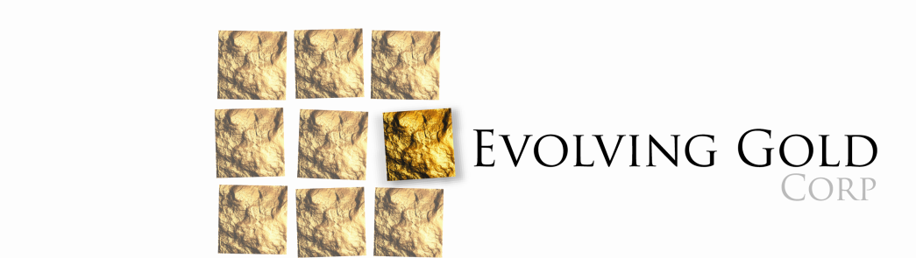

Update on Rattlesnake Property

March 2, 2016, Vancouver, British Columbia:
Evolving Gold Corp. (CSE: EVG) (FSE: EV7) (OTCB: EVOGF) (the “Company”)
By news dated July 29, 2015 the Company announced it had sold its Rattlesnake Property of GFG Resources (US) Inc. (“GFG”) for a combination of cash, shares and promissory note. As an update to that release, the Company advises:
1. it has received US$270,937.50 from the US$286,000 that was held in escrow;
2. it continues to hold 2,000,000 shares of GFG, and continues to have the right to hold at least 9% of the outstanding shares of GFG upon it obtaining a public listing of its shares on a North American stock exchange;
3. GFG extended its deadline to show significant progress toward obtain a public listing, from November 15, 2015 to February 15, 2016; and
4. the Company has requested and expects to receive an additional 200,000 common shares of GFG as a result of GFG not meeting its public listing progress deadline (and thereby be entitled to hold at least 9.9% of the outstanding shares of GFG upon it obtaining a public listing).

The Company continues to look forward to GFG obtaining a public listing of its shares; however the Company intends to dispose of its equity interest in GFG in advance of such date, including exercising its contractual right to put its shares to GFG on March 31, 2016 at US$0.25 per share, or other means.
On Behalf of the Board of Directors
EVOLVING GOLD CORP.
“R. Bruce Duncan”
CEO and Director
FOR MORE INFORMATION, PLEASE CONTACT:
Investor Relations:
Tel: 604.685.6375
TF: 866.604.3864
info@evolvinggold.com

Neither the Canadian Securities Exchange nor its Regulation Services Provider (as that term is defined in the policies of the Canadian Securities Exchange) accepts responsibility for the adequacy or accuracy of this release.

FORWARD LOOKING STATEMENTS: This news release contains forward-looking statements, which relate to future events or future performance and reflect management’s current expectations and assumptions. Such forward-looking statements reflect management’s current beliefs and are based on assumptions made by and information currently available to the Company. Investors are cautioned that these forward looking statements are neither promises nor guarantees, and are subject to risks and uncertainties that may cause future results to differ materially from those expected. Specifically, there is no guarantee as to the future value of the GFG shares held by the Company; that GFG will ever obtain a listing of its common shares on any stock exchange; or that GFG will have the means to acquire the GFG shares held by the Company in accordance with its contractual obligations. These forward-looking statements are made as of the date hereof and, except as required under applicable securities legislation, the Company does not assume any obligation to update or revise them to reflect new events or circumstances. All of the forward-looking statements made in this press release are qualified by these cautionary statements and by those made in our filings with SEDAR in Canada (available at www.sedar.com).

